**Kenya country profile**

Published

31 January 2018

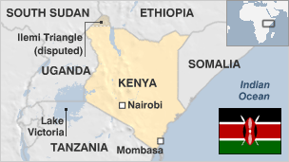

**Situated on the equator on Africa's east coast, Kenya has been described as "the cradle of humanity".**

In the Great Rift Valley palaeontologists have discovered some of the earliest evidence of man's ancestors.

In the present day, Kenya's ethnic diversity has produced a vibrant culture but is also a source of conflict.

The Islamist militant Al-Shabab movement, active in Somalia, has also been launching a growing number of attacks in Kenya, including the 2013 Westgate shopping mall in Nairobi and the 2015 attack on Garissa University College in northwest Kenya.

Other pressing challenges include high unemployment, crime and poverty. Droughts frequently put millions of people at risk.

* Read more [country profiles](http://news.bbc.co.uk/1/hi/country_profiles/) - Profiles by [BBC Monitoring](http://bbc.co.uk/monitoring)

**President: Uhuru Kenyatta**

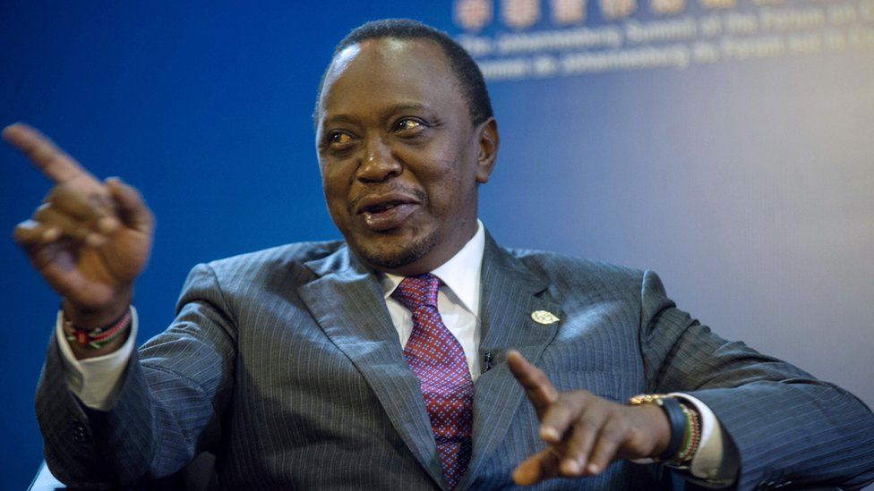image copyrightGetty Images

The son of Kenya's founding president, Uhuru Kenyatta took up his father's mantle to become head of state in April 2013, despite facing charges of crimes against humanity over election violence five years earlier.

Mr Kenyatta, ranked by Forbes as the richest man in Kenya, was born in 1961 shortly after the release of his father Jomo Kenyatta from nearly 10 years' imprisonment by British colonial forces, and two years before Kenya's independence.

Educated in the United States at the elite Amherst College, where he studied political science and economics, he is viewed as the top political leader of Kenya's largest tribe, the Kikuyu, who make up some 17% of the population.

However, he also appeals to Kenyans from different ethnic backgrounds, able to mingle not only with the elite he was born into but also with the average Kenyan, cracking jokes using local street slang.

He was declared winner of the presidential election in August 2017, but the Supreme Court declared the election null and void because of irregularities. He was also declared winner of the October re-run, which was boycotted by the opposition.

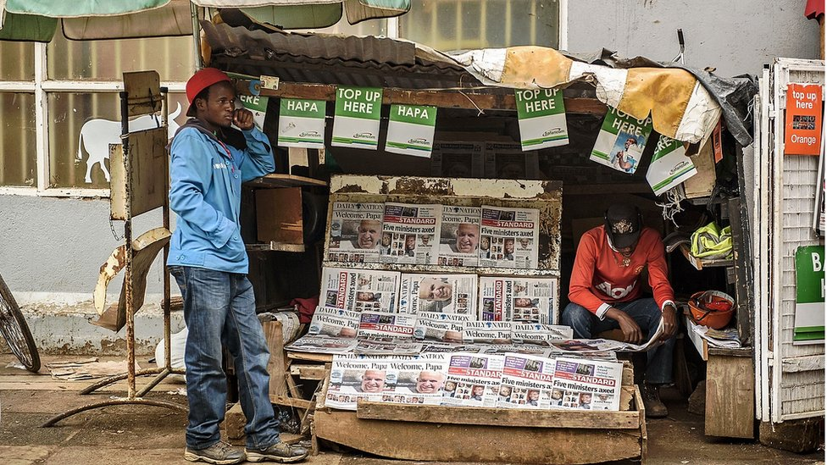image copyrightGetty Images

A handful of major commercial companies dominates the media industry, operating alongside state-owned Kenya Broadcasting Corporation (KBC).

TV is the main news source in urban areas. Internet use is high by regional standards, driven by the use of mobile devices.

The competitive press scene is the most sophisticated in the region. Newspapers are free to criticise politicians and the government.

**Kenya profile - Timeline**

Published

7 January

**A chronology of key events:**

**c 3.3 million BC** - Evidence of some of the earliest human tools have been found in Kenya, suggesting that it was the cradle of humanity from which descendents moved out to populate the world.

**600** - Arabs begin settling coastal areas, over the centuries developing trading stations which facilitated contact with the Arab world, Persia and India.

**1895** - Formation of British East African Protectorate.

**1920** - East African Protectorate becomes crown colony of Kenya - administered by a British governor.

**Mau Mau**

**1944** - Kenyan African Union (KAU) formed to campaign for African independence. First African appointment to legislative council.

**1947** - Jomo Kenyatta becomes KAU leader.

**1952-53** - Secret Kikuyu guerrilla group known as Mau Mau begins violent campaign against white settlers. State of emergency declared, Jomo Kenyatta jailed, KAU banned.

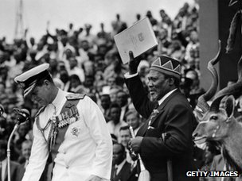image copyrightGetty Images

image captionJomo Kenyatta became Kenya's first post-independence leader in 1963

**1956** - Mau Mau rebellion put down.

**1960** - State of emergency ends. Britain announces plans to prepare Kenya for majority African rule. Kenya African national Union (Kanu) formed by Tom Mboya and Oginga Odinga.

**Independence**

**1961** - Jomo Kenyatta freed from two years of house arrest, assumes presidency of Kanu.

**1963** - Kenya gains independence, with Mr Kenyatta as prime minister.

**1964** - Republic of Kenya formed. Jomo Kenyatta becomes president and Oginga Odinga vice-president.

**1966** - Mr Odinga leaves Kanu after ideological split, forms Kenya People's Union (KPU).

**1969** - Assassination of government minister Tom Mboya sparks ethnic unrest. KPU banned and Mr Odinga arrested. Kanu only party to contest elections.

**1974** - Kenyatta re-elected.

**Moi era**

**1978** - Kenyatta dies in office, succeeded by Vice-President Daniel arap Moi.

**1982** June - Kenya officially declared a one-party state by National Assembly.

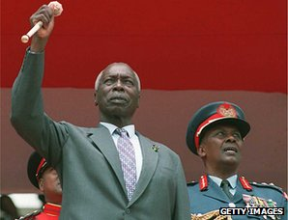image copyrightGetty Images

image captionDaniel arap Moi succeeded Jomo Kenyatta as president, stayed in office until 2002

**1987** - Opposition groups suppressed. International criticism of political arrests and human rights abuses.

**1991** August - Forum for the Restoration of Democracy (Ford) formed by six opposition leaders, including Oginga Odinga. Party outlawed and members arrested. Creditors suspend aid to Kenya amid fierce international condemnation.

**1991** December - Special conference of Kanu agrees to introduce a multi-party political system.

**1992** - Approximately 2,000 people killed in tribal conflict in the west of the country.

**Multi-party elections**

**1992** December - President Moi re-elected in multi-party elections. Kanu wins strong majority.

**1994** - Oginga Odinga dies. Opposition groups form coalition - the United National Democratic Alliance - but it is plagued by disagreements.

**1997** December - President Moi wins further term in widely-criticised elections. His main opponents are former vice-president Mwai Kibaki and Raila Odinga, son of Oginga Odinga.

**Embassy bomb**

**1998** August - Al-Qaeda operatives bomb the US embassy in Nairobi, killing 224 people and injuring thousands.

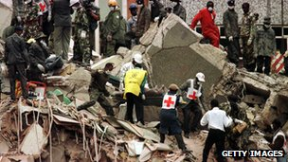image copyrightGetty Images

image captionMore than 200 people were killed when al-Qaeda bombed the US embassy in Nairobi

**2002** July - Some 200 Maasai and Samburu tribespeople accept more than $7m in compensation from the British Ministry of Defence. The tribespeople had been bereaved or maimed by British Army explosives left on their land over the last 50 years.

**2002** November - Al-Qaeda attack on Israeli-owned hotel near Mombasa kills 10 Kenyans and injures three Israelis. A simultaneous rocket attack on an Israeli airliner fails.

**Kibaki victory**

**2002** December - Elections. Mwai Kibaki wins a landslide victory, ending Daniel arap Moi's 24-year rule and Kanu's four decades in power.

**2004** October - Kenyan ecologist Wangari Maathai wins the Nobel Peace Prize.

**2005** November-December - Voters reject a proposed new constitution in what is seen as a protest against President Kibaki.

**2007** December - Disputed presidential elections lead to violence in which more than 1,500 die.

The government and opposition come to a power-sharing agreement in February and a cabinet is agreed in April.

**Constitution approved**

**2010** July - Kenya joins its neighbours in forming a new East African Common Market, intended to integrate the region's economy.

**2010** August - New constitution designed to limit the powers of the president and devolve power to the regions approved in referendum.

**2011** August-September - Somali al-Shabab jihadists raid Kenyan coastal resorts and a refugee camp, targeting foreigners.

**Troops in Somalia**

**2011** October - Kenyan troops enter Somalia to attack rebels they accuse of being behind several kidnappings of foreigners on Kenyan soil. Kenya suffers several reprisal attacks.

**2012** January - International Criminal Court rules that several prominent Kenyans must stand trial over the 2007 post-election violence.

**2012** March - Oil discovered. President Kibaki hails it as a ''major breakthrough''.

**2012** May - More than 30 people are injured in an attack on a Nairobi shopping centre by al-Shabab.

**2012** August-September - More than 100 people are killed in communal clashes over land and resources Coast Province.

Five people die in riots by Muslim protesters in Mombasa after the shooting of preacher Aboud Rogo Mohammed, accused by the UN of recruiting and funding al-Shabab Islamist fighters in Somalia.

**Kenyatta wins election**

**2013** March - Uhuru Kenyatta, the son of Kenya's first president, wins presidential election with just over 50% of the vote. A challenge to the results by his main rival, Prime Minister Raila Odinga, is rejected by the Supreme Court.

**2013** June - The British government says it sincerely regrets the torture of thousands of Kenyans during the suppression of the Mau Mau insurgency in the 1950s and promises £20m in compensation.

**2013** September - Deputy President William Ruto pleads not guilty at the International Criminal Court to crimes against humanity charges over the 2007 post-election violence.

**Al-Shabab steps up attacks**

**2013** September - Somali al-Shabab militants seize the Westgate shopping mall in Nairobi and kill more than 60 people, saying they want Kenya's military to pull out of Somalia.

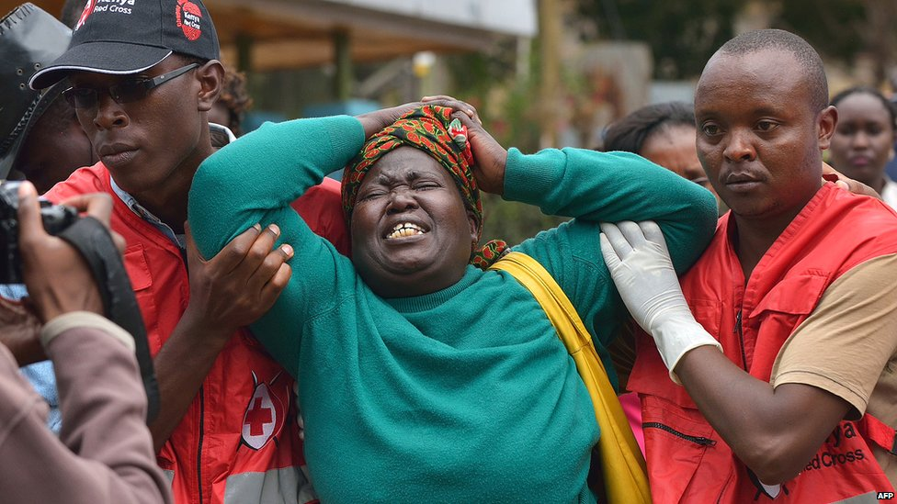image copyrightAFP

image captionThe massacre of 148 students at Garissa college in 2015 horrified Kenya and prompted criticism of the security forces

**2014** June - At 48 people die after al-Shabab militants attack hotels and a police station in Mpeketoni, near the island resort of Lamu.

**2014** December - Prosecutors at the International Criminal Court drop charges against President Kenyatta over the 2007 post-election violence, citing insufficient evidence.

**2015** April - Al-Shabab carry out a massacre at Garissa University College in northwest Kenya, killing 148 people.

**2017** February - Government declares a drought affecting a large part of the country to be a national disaster.

**2017** May - A new multi-billion-dollar railway line linking Mombasa to the capital Nairobi is opened - the country's biggest infrastructure project since independence.

**2017** August-October - President Kenyatta is declared winner of the presidential election in August as well as the re-run in October.

**2020** January - Al-Shabab Somali jihadists attack Camp Simba army base near Lamu, killing three Americans.